How to Handle Comments and Messages

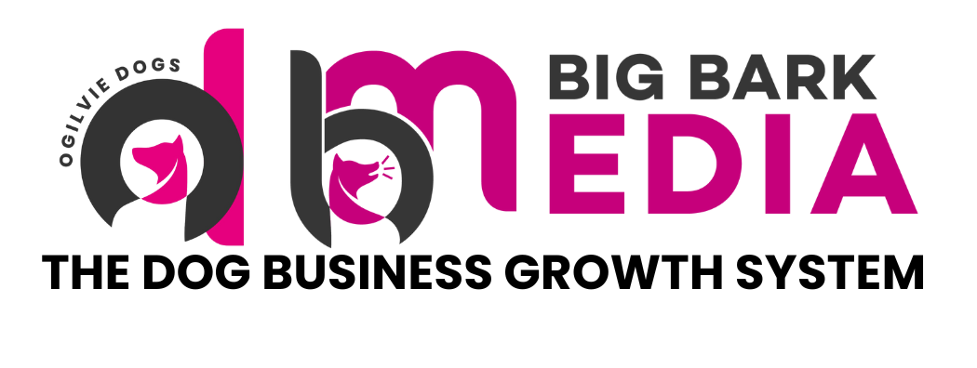

How to Handle Comments and Messages
Turning social media engagement into enquiries

One of the most overlooked parts of social media growth is how you respond to comments and messages.

Posting content attracts attention, but conversations are what turn viewers into clients. When someone comments on your post or sends a message, they are showing interest. How you respond in that moment can influence whether that interest develops into an enquiry.

This guide explains how to respond professionally and use engagement as an opportunity to build trust with potential clients.

Why Comments and Messages Matter
When someone interacts with your content, they are often looking for one or more of the following:

- Clarification
- Advice
- Reassurance
- Guidance
- Help with their dog's behaviour

Your response shows potential clients how knowledgeable, approachable and professional you are. It also demonstrates how you communicate, which is particularly important in a service based industry like dog training.

Responding to Comments
Comments are public conversations that other potential clients will see. For this reason, responses should always be helpful, professional and respectful.

When replying to comments:

- Acknowledge the person
- Provide a short and helpful response
- Encourage further conversation if appropriate

Example response:

"Great question. Many dogs struggle with recall when distractions increase. Start by practising in quieter environments before gradually adding more distractions."

Short, helpful responses demonstrate expertise without overwhelming the reader.

Encouraging Positive Engagement
Engagement helps your content reach more people. If someone comments positively on your content, take a moment to acknowledge it.

Simple responses work well here:

- "Thank you, I appreciate that."
- "Glad you found this helpful."
- "Great to hear this worked for you."

These short replies help create a welcoming and interactive community around your content.

Responding to Training Questions
Dog owners will often ask specific training questions in comments. Provide helpful guidance, but avoid trying to fully resolve complex behaviour issues in a comment section.

A balanced response might include:

- A short and practical explanation
- A reminder that behaviour issues are often individual to each dog
- An invitation to continue the conversation privately if appropriate

Example response:

"Reactivity can happen for many reasons and every dog is different. The key is understanding the underlying cause before working on behaviour change."

This keeps your response helpful while maintaining professional boundaries.

Handling Direct Messages
Direct messages often indicate stronger interest than comments. People may message you to ask questions about training or to enquire about your services.

When replying to messages:

- Respond politely and clearly
- Acknowledge their situation
- Guide them towards the next step if appropriate

Example response:

"Thanks for reaching out. It sounds like you are dealing with some lead reactivity. We work with many dogs experiencing similar challenges."

If the conversation relates to training support, you can then guide them naturally towards your enquiry or booking process.

Keeping Responses Professional
Your communication should always reflect the professionalism of your business. Maintain a tone that is:

- Friendly
- Calm
- Respectful
- Supportive

Avoid becoming defensive or argumentative, even if someone disagrees with your content or approach. Professional responses build trust with both the person commenting and anyone else reading the conversation.

Managing Negative Comments
Occasionally you may receive criticism or disagreement. In these situations:

- Remain calm and professional
- Avoid emotional or reactive responses
- Respond briefly if clarification would be genuinely helpful

If a comment is abusive or inappropriate, it is entirely reasonable to remove it or block the user. Your page should remain a respectful space for discussion and learning.

Turning Conversations Into Enquiries
When someone expresses interest in training support, it is appropriate to guide them towards the next step. This might include:

- Directing them to your website
- Encouraging them to book a consultation
- Inviting them to share more details about their situation

The goal is not to pressure people, but to make the next step as clear and easy as possible.

The Key Principle
Content attracts attention. Conversations build trust. Trust leads to enquiries.

By responding thoughtfully and professionally to comments and messages, you turn social media engagement into meaningful opportunities to help dog owners and grow your training business.

