The 7 Second Profile Test

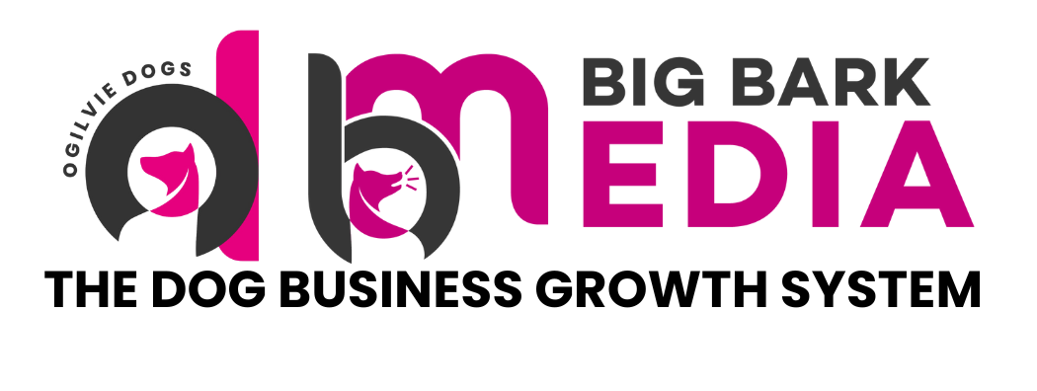

The 7 Second Profile Test
How to check if your social media profile converts visitors into enquiries

When someone lands on your social media profile, they decide very quickly whether to stay or leave. Most people make this decision in less than seven seconds.

This means your profile must immediately communicate who you help, what you do and why someone should trust you. If your profile is unclear, potential clients will simply move on to the next trainer.

Use the following checklist to evaluate whether your profile passes the 7 second test.

1. Profile Photo
Your profile image is the first visual impression of your brand. For dog trainers, the most effective option is usually a clear photo of you with a dog.

Best practice:

- Clear head and shoulders photo
- Natural lighting
- Neutral or uncluttered background
- Friendly and confident expression

Avoid:

- Dark or blurry photos
- Group pictures
- Small or unreadable logos

The goal is to appear approachable, professional and trustworthy.

2. Bio Clarity
Your bio should instantly answer four questions:

- Who do you help?
- What problem do you solve?
- Where are you based?
- What should someone do next?

If someone cannot understand these four points within a few seconds, your bio is too unclear. Keep it simple, structured and easy to scan.

3. Location Visibility
Dog training is a local service for most businesses. Your location should be clearly visible within your profile so potential clients know you operate in their area. For example:

- Hertfordshire
- London and surrounding areas
- Guernsey
- UK online coaching

This helps local dog owners quickly recognise that you can help them.

4. Pinned Content
Pinned posts are often the first pieces of content people will see when visiting your page. Your pinned posts should help answer key questions such as:

- What type of training you provide
- The problems you specialise in solving
- Examples of results with clients

Pinned posts act as a quick introduction to your expertise and should be chosen carefully.

5. Story Highlights
Story highlights help organise important information and make your profile easier to explore. Useful highlight sections may include:

- Client results
- Training tips
- Puppy advice
- Behind the scenes
- Frequently asked questions

Highlights should be clearly labelled and visually consistent so they are easy to navigate.

6. The First Nine Posts
Many people scan the first nine posts on your grid to get a feel for what your page is about. Ask yourself:

- Does my content look consistent and professional?
- Is it immediately clear that I am a dog trainer?
- Would a potential client feel confident contacting me after viewing my grid?

Your profile grid should quickly communicate expertise and professionalism at a glance.

Final Profile Checklist
Before finishing your profile setup, confirm each of the following:

- Clear and professional profile photo
- Bio that explains who you help and what you do
- Location clearly visible
- Strong and relevant pinned posts
- Organised and labelled story highlights
- Consistent and professional looking content grid

If your profile passes the 7 second test, visitors are far more likely to follow you and enquire about your services.

