Hook Ideas for Dog Trainers

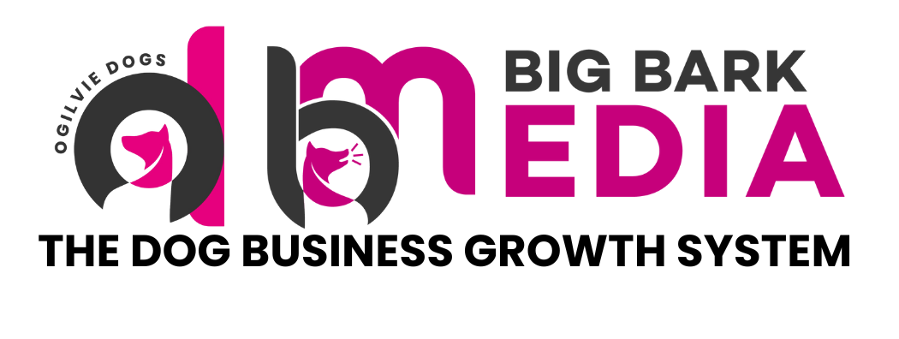

Hook Ideas for Dog Trainers
Opening lines that capture attention

The first few seconds of a video determine whether someone continues watching or scrolls past.

Strong hooks highlight a problem, create curiosity or present a surprising insight. Below are examples of hooks that can be used across a wide range of training topics.

Problem Based Hooks
These hooks work by naming a specific frustration or mistake that your audience will immediately recognise.

- The biggest mistake dog owners make with recall
- If your dog pulls on the lead, this could be why
- Most people accidentally train their dog to ignore them
- Why your dog listens at home but not outside
- This is why your dog keeps jumping on guests

Curiosity Hooks
These hooks create a sense of intrigue and encourage the viewer to keep watching to find out more.

- Something most dog owners do that actually makes behaviour worse
- A simple change that can improve your dog's focus instantly
- One thing that can completely change your dog's recall
- This small training mistake causes big problems later
- A quick test to see if your dog is actually listening

Relatable Hooks
These hooks work by reflecting a common experience back to the viewer, making them feel seen and understood.

- If walks with your dog feel stressful, watch this
- If your dog ignores you in the park, you are not alone
- Many dog owners struggle with this behaviour
- This is one of the most common problems I see in training sessions
- Here is what most puppy owners experience in the first few months

Authority Hooks
These hooks position you as an experienced professional and signal that the viewer is about to hear something worth listening to.

- After working with hundreds of dogs, this is something I see often
- One training mistake I correct almost every week
- A common behaviour problem explained by a trainer
- Here is what I look for when assessing a dog's behaviour
- A simple training principle that many people overlook

Tips for Using Hooks Effectively
- Match the hook to the content. Your video must deliver on whatever the hook promises. If it does not, viewers will drop off quickly and lose trust in your content.
- Keep hooks short and direct. One or two sentences is usually enough. The hook should create a reason to keep watching, not explain the whole video upfront.
- Test different hook styles. Pay attention to which types of hooks generate the most views and watch time on your own profile, then use more of what works.
- Speak the hook on camera. Saying your hook out loud at the very start of a video is just as important as having it as on-screen text. Use both together for the strongest effect.

Call To Action Ideas

Call to Action Ideas
Encouraging viewers to take the next step

Calls to action guide viewers towards the next step after watching your content. Without a clear call to action, most people will consume your content and move on without doing anything.

These prompts can appear either on screen within the video itself, or within the caption or description below the post.

On Screen Call to Action Ideas
These are short prompts displayed as text within the video. They should appear towards the end of the video and be clear and direct.

- Follow for more dog training tips
- Save this for your next training session
- Read the caption for more details
- Share this with a dog owner who needs it
- More training tips on my page
- Visit the link in my bio
- Book your training consultation
- Send this to a friend with a dog

Caption Call to Action Ideas
These are prompts placed at the end of your caption to encourage a specific action after reading.

- Drop a comment below if this sounds familiar
- Save this post so you can come back to it later
- Share this with someone whose dog does this
- Follow for more tips like this every week
- Click the link in my bio to book a session
- Tell me in the comments which one your dog does
- Tag a friend who needs to see this
- Send me a message if you would like help with this

Enquiry and Booking Call to Action Ideas
These are calls to action aimed specifically at converting viewers into leads or clients.

- Apply to work with me using the link in my bio
- Send me a message to find out how I can help
- Book a free discovery call using the link below
- Limited spaces available, message me to find out more
- Visit my website to see how we can work together
- Fill in my enquiry form using the link in my bio

Tips for Using Calls to Action Effectively
- Use one call to action per post. Giving viewers too many options often results in them doing nothing. Pick the single most important action you want them to take.
- Match the call to action to your goal. If your goal is reach, ask people to share or send. If your goal is followers, ask people to follow. If your goal is enquiries, direct people to your bio link or messages.
- Keep it short and specific. A clear and direct instruction works better than a vague one. "Save this for your next session" outperforms "feel free to save this if you found it useful."
- Include a call to action in every post. Even a simple one. Content without a next step rarely builds momentum.

