Social Media Tools Guide

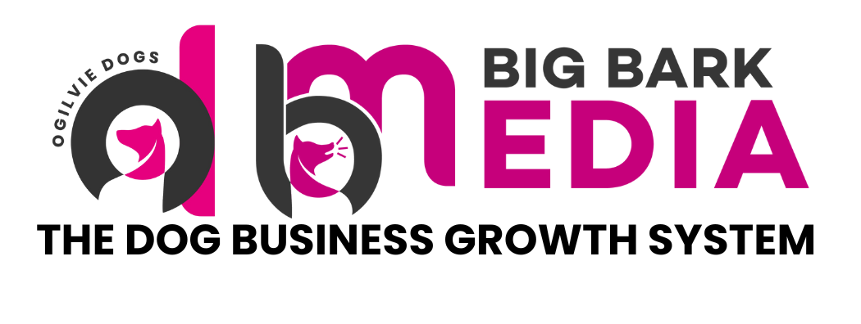

Social Media Tools Guide
A practical resource for creating and managing content on Instagram, TikTok and Facebook

Building a strong social media presence does not require expensive equipment or complicated software. The most successful dog trainers online simply use a small set of reliable tools that help them create content consistently, stay organised and understand what is working.

Below is a selection of useful tools that can support your content creation, planning and growth.

Free Tools

Canva
A user friendly design platform that allows you to create professional looking social media content quickly. Canva is ideal for producing post graphics, carousels, story templates, thumbnails and simple video edits.

You can save your brand colours, fonts and templates so that all of your content remains visually consistent. This makes it much easier to maintain a professional and recognisable brand identity across Instagram, TikTok and Facebook.

CapCut
A powerful video editing tool designed specifically for short form content. CapCut works on both mobile and desktop and is widely used by creators producing Reels and TikTok videos.

It allows you to add captions, adjust clips, include trending sounds and apply simple transitions. These features help improve viewer retention and make your videos feel more polished without requiring advanced editing skills.

Meta Business Suite
Meta Business Suite allows you to manage both Facebook and Instagram from one central dashboard.

You can schedule posts, reply to comments and messages, and review performance analytics. This tool is particularly useful for staying organised and understanding which content is generating engagement or enquiries.

ChatGPT
A helpful assistant for generating ideas, writing captions and structuring content.

It can support you with hook ideas, post outlines, educational captions and content planning. This is particularly useful when you feel stuck for ideas or want to speed up your content creation process.

Google Trends
Google Trends shows what people are currently searching for online.

This can help you identify seasonal topics, popular questions and emerging trends. Aligning your content with topics people are actively searching for can increase the relevance and discoverability of your posts.

AnswerThePublic
AnswerThePublic gathers real questions that people are asking online about specific topics.

For dog trainers this can be extremely valuable for identifying common problems dog owners are trying to solve. These questions can easily be turned into educational videos, carousel posts or helpful tips.

Trello
Trello is a simple visual organisation tool that works well for planning social media content.

You can create boards for content ideas, upcoming posts and published content. This helps you stay consistent and ensures that useful ideas are never forgotten.

Paid Tools

Later
Later is a scheduling platform designed specifically for visual social media platforms.

It allows you to plan your Instagram feed visually, schedule posts in advance and manage hashtags. This is useful if you want a structured posting system and a more organised content workflow.

Metricool
Metricool provides deeper analytics across multiple social media platforms.

It allows you to track follower growth, engagement rates and post performance so you can better understand what type of content resonates with your audience.

ManyChat
ManyChat is an automation tool designed for Instagram and Facebook direct messages.

It is particularly effective for lead generation campaigns, such as asking viewers to comment a keyword in order to receive a guide, checklist or resource. This can help turn social media engagement into enquiries and leads.

Mailchimp
Mailchimp helps turn social media followers into long term subscribers.

By encouraging followers to join your email list, you can build a direct communication channel for sharing updates, training tips and offers. Email marketing remains one of the most reliable ways to nurture leads and convert enquiries into paying clients.

InShot
InShot is a mobile video editing tool that provides additional editing flexibility for short form videos.

It allows precise clip trimming, caption placement and aspect ratio adjustments, which can be helpful when preparing content for different social platforms.

Adobe Express
Adobe Express offers more advanced design capabilities while remaining easy to use.

It is well suited for creating branded graphics, animated posts and more refined visual content once your brand identity is established.

Hootsuite
Hootsuite is a comprehensive social media management platform designed for businesses managing multiple channels.

It allows scheduling across platforms, team collaboration and detailed reporting. This tool is particularly useful for businesses that are scaling their online presence and need a more structured management system.

Quick Reference
Tool | Cost | Best For
Canva | Free | Graphics, carousels, templates
CapCut | Free | Reels and TikTok video editing
Meta Business Suite | Free | Scheduling and managing Facebook and Instagram
ChatGPT | Free | Caption ideas, hooks and content planning
Google Trends | Free | Identifying trending and seasonal topics
AnswerThePublic | Free | Finding questions your audience is asking
Trello | Free | Content planning and organisation
Later | Paid | Visual Instagram scheduling
Metricool | Paid | Analytics and performance tracking
ManyChat | Paid | DM automation and lead generation
Mailchimp | Paid | Email list building and marketing
InShot | Paid | Mobile video editing
Adobe Express | Paid | Advanced branded graphics
Hootsuite | Paid | Multi-platform scheduling and reporting

